**\*\*\*\*\*\*\*\*\*\*\*\*\*\*\*\*\*\*Basic Demo**********************************************8**

<!DOCTYPE html>

<html lang="en">

<head>

<title>HTML5 Skeleton</title>

<meta charset="utf-8">

<!-- Content in style tag will be explained during CSS 3.0 session -->

<style>

body

{

font-family: Verdana, sans-serif; font-size:0.8em;

}

header,nav, section,article,footer,figure

{

border:1px solid grey; margin:5px; padding:8px;

}

nav ul

{

margin:0; padding:0;

}

nav ul li

{

display:inline; margin:5px;

}

</style>

</head>

<body>

<header>

<h1>HTML5 SKeleton</h1>

</header>

<nav>

<ul>

<li><a href="Semantic.htm">HTML5 Semantic</a></li>

<li><a href="Forms.htm">HTML5 Forms</a></li>

<li><a href="Graphics.htm">HTML5 Graphics</a></li>

</ul>

</nav>

<section>

<h1>Famous Cities</h1>

<article>

<h2>London</h2>

<p>London is the capital city of England. It is the most populous

city in the United Kingdom, with a metropolitan area of over 13

million inhabitants.</p>

</article>

<article>

<h2>Paris</h2>

<p>Paris is the capital and most populous city of France.</p>

<aside>Every fashion starts here</aside>

</article>

<article>

<h2>Tokyo</h2>

<p>Tokyo is the capital of Japan, the center of the Greater Tokyo

Area, and the most populous metropolitan area in the world.</p>

</article>

<aside> Body Section....

<aside>

</section>

<footer>

<p>&copy; 2015 IGATE Corporate University. All rights reserved.</p>

</footer>

</body>

</html>

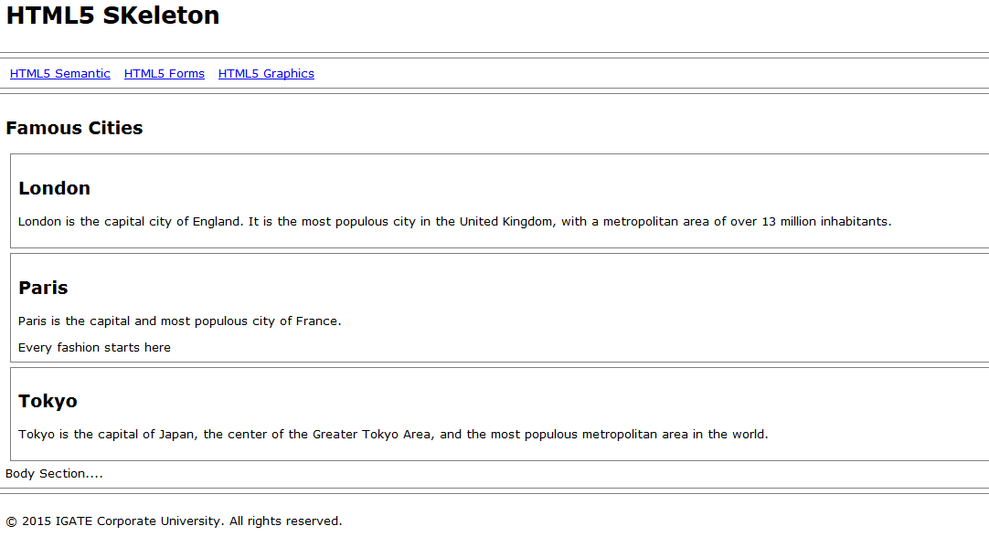

**\*\*\*\*\*\*\*\*\*\*\*\*\*\*\*\*\*\*\*\*\*\*\*\*\*\*\*\*\*\*\*\*\*\*\*\*\*\*\*\*\*\*thead.html\*\*\*\*\*\*\*\*\*\*\*\*\*\*\*\*\*\*\*\*\*\*\*\***

<!DOCTYPE html>

<html>

<head>

<style>

thead {color:green;}

tbody {color:blue;}

tfoot {color:red;}

table, th, td {

border: 1px solid black;

}

</style>

</head>

<body>

<table>

<thead>

<tr>

<th>Month</th>

<th>Savings</th>

</tr>

</thead>

<tbody>

<tr>

<td>January</td>

<td>$100</td>

</tr>

<tr>

<td>February</td>

<td>$80</td>

</tr>

</tbody>

<tfoot>

<tr>

<td>Sum</td>

<td>$180</td>

</tr>

</tfoot>

</table>

<p><b>Tip:</b> The thead, tbody, and tfoot elements will not affect the layout of the table by default. However, you can use CSS to style these elements.</p>

</body>

</html>

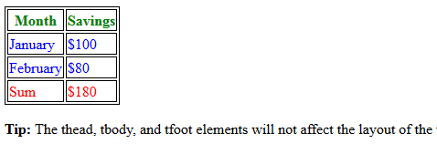

**\*\*\*\*\*\*\*\*\*\*\*\*\*\*\*\*\*\*\*\*\*\*colgroup.html\*\*\*\*\*\*\*\*\*\*\*\*\*\*\*\*\*\*\*\*\*\*\*\*\*\*\*\*\*\*\*\*\***

<!DOCTYPE html>

<html>

<head>

<style>

table, th, td

{

border: 1px solid black;

}

</style>

</head>

<body>

<table>

<colgroup>

<col span="2" style="background-color:red">

<col style="background-color:yellow">

</colgroup>

<tr>

<th>ISBN</th>

<th>Title</th>

<th>Price</th>

</tr>

<tr>

<td>3476896</td>

<td>My first HTML</td>

<td>$53</td>

</tr>

<tr>

<td>5869207</td>

<td>My first CSS</td>

<td>$49</td>

</tr>

</table>

</body>

</html>

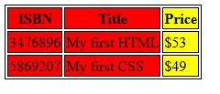

**\*\*\*\*\*\*\*\*\*\*\*\*\*\*\*\*\*\*\*\*\*\*\*\*\*\*\*\*\*\*\*\*\*imagealign.html\*\*\*\*\*\*\*\*\*\*\*\*\*\*\*\*\*\*\***

<!DOCTYPE html>

<html>

<head>

</head>

<body>

<h1 align="center">The Example of image alignment</h1>

<hr>

<p>

<IMG src="mercury.png" alt="Mercury" style="float: left">

<br

clear="right" />

<p>HTML allows for simple aligning of text and images by adding the

style attributes to the tag. HTML 5 expanded this attribute by

specifying float:left and float:right options. When you use these

options, text flows down the right or left side of an image aligned to

them. The text flow continues until either the text passes the image,

the text ends, or the browser encounters a tag.

<p></p>

<br>

<br>

<br>

<hr>

<IMG src="mercury.png" alt="Home" style="float: right">

<br clear="left" /> HTML5 allows vertical alignment of text and images

by adding the style attribute with values as vertical-align:bottom,

vertical-align:top,.. When you use these options, text is vertically

aligned top/bottom/middle. The text flow continues until either the

text passes the image, the text ends, or the browser encounters a br

tag with clear attribute.

<p></p>

<br>

<br>

<br>

<hr>

<IMG src="mercury.png" alt="Home" style="vertical-align: bottom">

<BR CLEAR=”all”> HTML5 allows vertical alignment of text and

images by adding the style attribute with values as

vertical-align:bottom, vertical-align:top,.. When you use these

options, text is vertically aligned top/bottom/middle. The text flow

continues until either the text passes the image, the text ends, or the

browser encounters a br tag with clear attribute.

<br>

<br>

<br>

<hr>

<p>

<IMG src="mercury.png" alt="Mercury" style="vertical-align: top">

<p>

HTML5 allows vertical alignment of text and images by adding the style

attribute with values as vertical-align:bottom, vertical-align:top,..

When you use these options, text is vertically aligned

top/bottom/middle. The text flow continues until either the text

passes the image, the text ends, or the browser encounters a br tag

with clear attribute.<BR CLEAR="Left/Right/all">

<p></p>

<br>

<br><br> <hr><body></html>

**\*\*\*\*\*\*\*\*\*\*\*\*\*\*\*\*\*\*\*\*\*\*\*\*\*\*\*\*IFrame\*\*\*\*\*\*\*\*\*\*\*\*\*\*\*\*\*\*\*\*\*\*\***

* *Inline Frame Element* (<iframe>) is used to embed another HTML page into the current page.
* <iframe> can be used within a HTML document body just like an <img> tag.
* A section that contains embedded content is called the parent context.
* Types of documents which can be embed using IFRAME are
  + Image(GIF, JPEG, etc..)
  + PDF
  + Audio
  + Video
  + HTML document, etc..
* Advantages of using IFRAME
  + Common content like header, footer, .. For multiple pages can be described using IFRAME
  + By displaying advertisement, web page can be promoted easily.

**\*\*\*\*\*\*\*\*\*\*\*\*\*\*\*\*\*\*\*\*\*\*\*\*\*\*\*\*\*\*\*\*\*\*\*iframe.html\*\*\*\*\*\*\*\*\*\*\*\*\*\*\*\*\*\*\*\*\***

<!DOCTYPE html>

<html>

<body>

<iframe src="HTML5.pdf" width="600" height="400">

<p>Your browser does not support iframes.</p>

</iframe>

<p>Inline Frame Element  is used to embed another HTML page into the current page. can be used within a HTML document body just like an tag. A section that contains embedded content is called the parent context.</p>

</body>

</html>

**\*\*\*\*\*\*\*\*\*\*\*\*\*\*\*iframedemo2.html\*\*\*\*\*\*\*\*\*\*\*\*\*\*\*\*\*\*\*\*\*\*\*\*\*\*\*\*\*\*\***

<!DOCTYPE html>

<!-- Open in Google Chrome -->

<HTML>

<HEAD><TITLE>Frames</TITLE></HEAD>

<BODY>

<iframe src="blank.html" width="1350" height="200" name="Header">

</iframe>

<iframe src="parent.html" width="1350" height="200">

</iframe>

<iframe srcdoc="<h1>Footer Page</h1>" width="1350" height="200">

</iframe>

</BODY>

</HTML>

**\*\*\*\*\*\*\*\*\*\*\*\*\*\*\*\*\*\*\*\*\*\*\*\*\*\*\*\*\*blank.html\*\*\*\*\*\*\*\*\*\*\*\*\*\*\*\*\*\*\*\*\*\*\*\*\*\***

<h1>This is blank HTML page</h1>

**\*\*\*\*\*\*\*\*\*\*\*\*\*parent.html\*\*\*\*\*\*\*\*\*\*\*\*\*\*\*\*\*\*\*\*\*\*\*\*\*\*\*\*\*\*\*\*\*\***

<!DOCTYPE html>

<html>

<head>

<title>Parent page</title>

</head>

<body>

<a href="self.html" target="_self">self</a><br>

<a href="blank.html" target="_parent">parent</a><br>

<a href="top.html" target="_top">Top</a><br>

<a href="left.html" target="_blank">blank</a><br>

<a href="header.html" target="Header">Header</a>

</body>

</html>

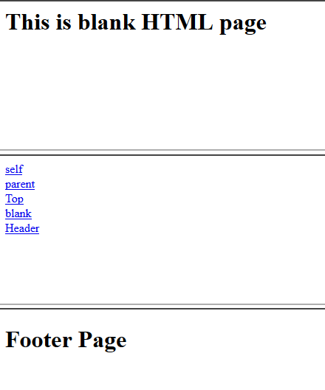

**\*\*\*\*\*\*\*\*\*\*\*\*\*\*\*\*\*\*\*\*\*\*\*\*\*\*\*\*\*\*New Form Element\*\*\*\*\*\*\*\*\*\*\*\*\*\*\*\*\*\*\*\*\*\*\*\*\*\*\*\***

<html>

<head>

<meta name="viewport" content="height=device-height,width=device-width,user-scalable=no" />

<meta charset="UTF-8">

<title>New Form Elements</title>

</head>

<body>

<form name="Formelements" action="index2.jsp">

<!-- supported only on Google Chrome/Safari -->

<table>

<tr>

<td><label for="demo">Placeholder : </label></td>

<td><input id ="demo" name="demo"

placeholder="Enter Numbers Only" /></td>

</tr>

<tr>

<td><label for="nameauto">Autofocus : </label></td>

<td><input id ="nameauto" name="nameauto"

type="text" autofocus/></td>

</tr>

<tr>

<td><label for="range">Range : </label></td>

<td><input id="range" name="range" type="range"

min="0" max="50" value="10" /><td>

</tr>

<tr>

<td><label for="search">Search : </label></td>

<td><input id="search" name="search"

type="search" placeholder="Search..." /><td>

</tr>

<!-- supported only on Safari -->

<!-- supported only on Opera 10.5 onwards -->

<tr>

<td><label for="date">Date : </label></td>

<td><input id="date" name="date"

type="date" min="2010-08-14"

max="2014-08-14" value=""/></td>

</tr>

<tr>

<td><label for="date">Week : </label></td>

<td><input id="date" name="date"

type="week" value=""/></td>

</tr>

<tr>

<td><label for="date">Month : </label></td>

<td><input id="date" name="date"

type="month" value=""/></td>

</tr>

<tr>

<td><label for="date">Time : </label></td>

<td><input id="date" name="date"

type="time" value=""/></td>

</tr>

<tr>

<td><label for="number">Number : </label></td>

<td><input id="number" name="number" type="number"

step="1" min="-5" max="10" value="0" /><td>

</tr>

<tr>

<td><label for="required">Required : </label></td>

<td><input id="required" name="user"

type="text" required /></td>

</tr>

<tr>

<td><label for="email">Email:</label></td>

<td><input id="email" name="email" type="email" required/></td>

</tr>

<!-- supported only on Opera 10.5 onwards -->

<!-- supported only on Opera 11 displays color picker on browser -->

<tr>

<td><label for="color">Color : </label></td>

<td><input id="color" name="color" type="color" placeholder="e.g. #bbbbbb" /><td>

</tr>

<!-- supported only on Opera 11 -->

<!-- supported only on Opera 11 and Firefox 4 -->

<tr>

<td><label for="country_name">Country : </label></td>

<td><input id="country_name" name="country_name" type="text" list="country" /></td>

<td><datalist id="country">

<option value="Afghanistan">

<option value="Albania">

<option value="Algeria">

<option value="Andorra">

<option value="Angola">

<option value="Car">

<option value="Cat">

<option value="City">

<option value="Cup">

<option value="Clip">

</datalist></td>

</tr>

<tr><td colspan="2"><audio controls >

<source src= "god.mp3" type="audio/mpeg" />

<source src= "myown.ogg" type="audio/ogg"/>

</audio></td></tr>

<!-- audio code works on Firefox and opera .ogg format only -->

<tr>

<td colspan="2">

<video src="http://upload.wikimedia.org/wikipedia/commons/7/79/Big_Buck_Bunny_small.ogv" controls width="300" height="250">

</video></td></tr>

<!-- Video code works only on Firefox. .ogg format. various ogg file extension are .ogx, .ogv, .oga, .spx. -->

</table>

<table>

<tr>

<td align="right"><button type="submit" name="submit" value="Submit">Submit</button></td>

<td align="left"><button type="reset" name="reset" value="reset">Reset</button></td>

</tr>

<tr>

<td>Pincode:

<input type="text" name="pin_code"

pattern="[0-9]{6}" title="666666">

</td>

</tr>

</table>

</form>

</body>

</html>

Modernizr is a JavaScript library that helps you add HTML5 capabilities to your

websites. HTML5 is a combination of HTML, JavaScript, and CSS3. The problem

with HTML5 is that not all browsers support HTML5 markup and those that do

support it, do not always support it the same way. Modernizer helps you get a

consistent experience for your end users across multiple browsers. Even older

browsers like Internet Explorer 6 can benefit from Modernizr.

Modernizr detects the actual HTML5 features that a browser supports. It does this by

first creating an element, setting a style instruction on the element, and then

retrieving it. If a browser does not support the instruction, it will return an error or

undefined.

The first thing you need to do is get the Modernizr library. There are two ways to do

this. First, you can use a Content Delivery Network (CDN) like the one from

Microsoft. The second (and best) way is to use a custom build from Modernizr.com

This option allows you to choose only the portions you want. This results in a smaller

file.

**\*\*\*\*\*\*\*\*\*\*\*\*\*\*\*\*Modernizer\*\*\*\*\*\*\*\*\*\*\*\*\*\*\*\*\*\*\*\*\*\*\*\*\*\*\*\*\*\*\*\*\*\*\*\*\*\*\*\*\*\*\*\*\***

<!DOCTYPE html>

<!-- Open in Google Chrome-->

<html>

<head>

<meta name="viewport"

content="height=device-height,

width=device-width,user-scalable=no" />

<script src="modernizr-1.5.min.js"></script>

<meta charset="UTF-8">

<title>Modenizer Page</title>

</head>

<script type="text/javascript">

function videoChk()

{

if (Modernizr.video.mp4)

{

alert("You got mp4");

}

else if (Modernizr.video.ogg)

{

alert("You got ogg");

}

else

{

alert("No Video Support");

}

}

</script>

<body>

<input type="button" value="Check for video" onclick="videoChk()">

</body>

</html>

**\*\*\*\*\*\*\*\*\*\*\*\*\*\*\*\*Canvas\*\*\*\*\*\*\*\*\*\*\*\*\*\*\*\*\*\*\*\*\*\*\*\*\*\*\*\*\*\*\*\*\*\*\*\*\*\*\*\*\*\*\*\*\*\*\*\*\*\*\*\*\*\*\*\***

**Canvas**

HTML5 defines the <canvas> element as “a resolution-dependent bitmap canvas that

can be used for rendering graphs, game graphics, or other visual images on the fly.”

A canvas is a rectangle in your page where you can use JavaScript to draw anything

you want. HTML5 defines a set of functions (“the canvas API”) for drawing shapes,

defining paths, creating gradients, and applying transformations.

If your browser supports the canvas API, the DOM object it creates to represent

a <canvas> element will have a getContext() method. If your browser doesn’t support

the canvas API, theDOM object it creates for a <canvas> element will only have the

set of common properties, but not anything canvas-specific.

***function supports_canvas()***

***{ return !!document.createElement('canvas').getContext; }***

This function starts by creating a dummy <canvas> element. But the element is

never attached to your page, so no one will ever see it. It’s just floating in memory,

going nowhere and doing nothing.

**\*\*\*\*\*\*\*\*\*\*\*\*\*\*\*\*\*\*\*\*\*\*\*\*\*Canvas Demo2.html\*\*\*\*\*\*\*\*\*\*\*\*\*\*\*\*\*\*\*\*\*\*\*\*\*\*\*\*\*\*\*\*\*\*\*\*\***

<!DOCTYPE html>

<html>

<body>

<p>Image to use:</p>

<img id="scream" src="mercury.png"

alt="The Mercury Image " width="220" height="277">

<p>Canvas to fill:</p>

<canvas id="myCanvas" width="250" height="300"

style="border:1px solid #d3d3d3;">

Your browser does not support the HTML5 canvas tag.

</canvas>

<p><button onclick="myCanvas()">Try it</button></p>

<script>

function myCanvas()

{

var c = document.getElementById("myCanvas");

var ctx = c.getContext("2d");

var img = document.getElementById("scream");

ctx.drawImage(img,10,10);

}

</script>

</body>

</html>

**\*\*\*\*\*\*\*\*\*\*\*\*\*\*\*\*\*\*\*\*\*\*\*\*\*\*\*\*\*\*\*\*\*Thank You*******************************************.**

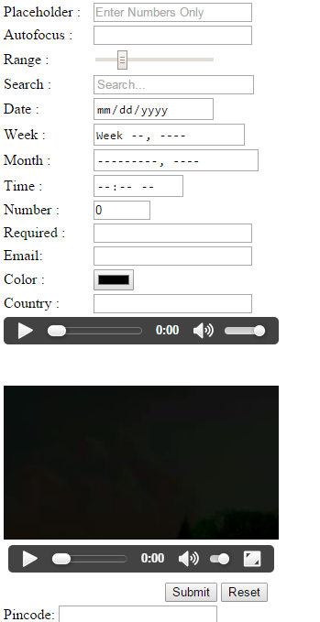

**\*\*\*\*\*\*\*\*\*\*\*\*\*\*\*\*\*\*\*\*\*\*\*table-Span.htm\*\*\*\*\*\*\*\*\*\*\*\*\*\*\*\*\*\*\*\*\*\***

<!DOCTYPE html>

<html>

<head>

<title>Table RowSpan and ColSpan Example</title>

</head>

<table border=1>

<tr>

<th>Deptno</th><th>Name</th><th>Salary</th>

</tr>

<tr>

<td rowspan="2">10</td>

<td>Sita</td>

<td>34000</td>

</tr>

<tr>

<td>Ram</td>

<td>24000</td>

</tr>

<tr>

<td rowspan="3">20</td>

<td>Laksman</td>

<td>45000</td>

</tr>

<tr>

<td>Lava</td>

<td>32000</td>

</tr>

<tr>

<td>Kusha</td>

<td>42000</td>

</tr>

<tr style="background-color:skyblue">

<td colspan="2">Total Salary</td>

<td>1222</td>

</tr>

</table>

</body>

<html>

********************output********************

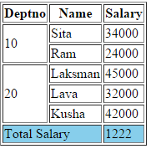

**\*\*\*\*\*\*\*\*\*\*\*\*\*\*\*\*\*\*\*\*\*\*colgroup.html\*\*\*\*\*\*\*\*\*\*\*\*\*\*\*\*\***

<!DOCTYPE html>

<html><head><title>Table with Colgroup</title></head>

<body>

<table>

<colgroup span="3" style="background-color:orange">

<colgroup span="4" style="background-color:lightgreen">

<tr>

<th colspan="3">Ecommerce Stream</th>

<th colspan="4">Mainframe Stream</th>

<tr>

<td>Internet/HTML<td>Javscript<td>Java

<td>CICS<td>COBOL<td>JCL<td>IMS

<tr>

<td>JSP<td>Servlet<td>Struts

<td>ADS/O<td>VSAM<td>IDMS<td>MVS

</table>

</html>

**\*\*\*\*\*\*\*\*\*\*\*\*\*\*\*\*output\*\*\*\*\*\*\*\*\*\*\*\*\*\*\*\*\*\*\*\*\*\*\*\*\*\*\*\*\*\*\*\*\*\***

